3.1)

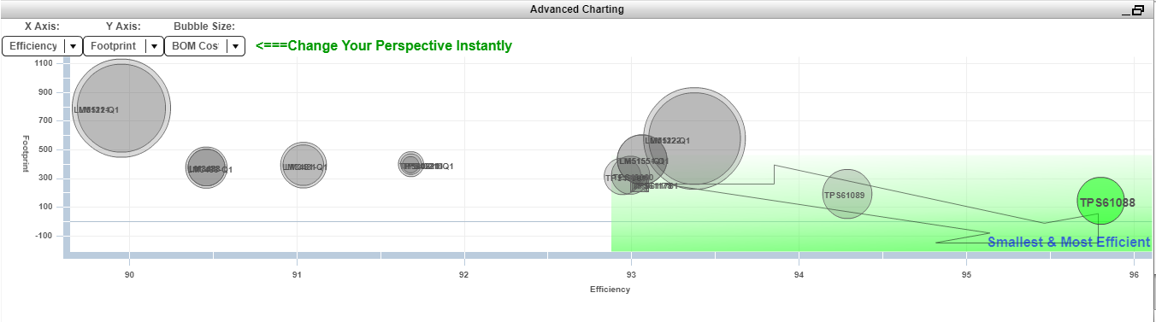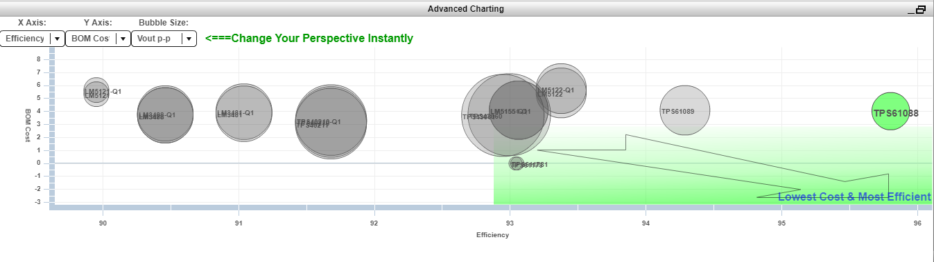Figure x – Efficieny vs Footprint Chart of the step-up converters (Bubble size shows the Bom Cost).

Figure x - Efficieny vs Bom Cost Chart of the step-up converters (Bubble size shows the Vout p-p).

3.2)

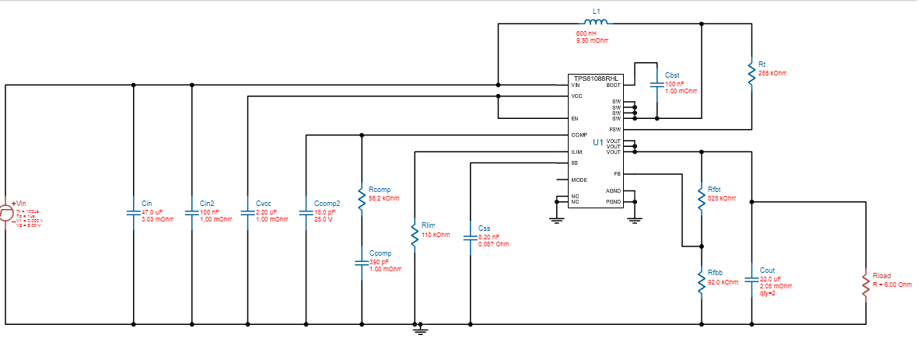

Figure x – Circuit schematic of the chosen step – up converte TPS61088.

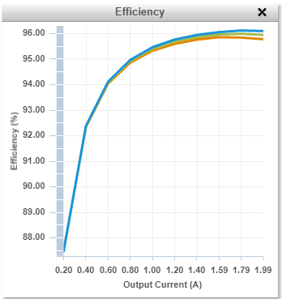 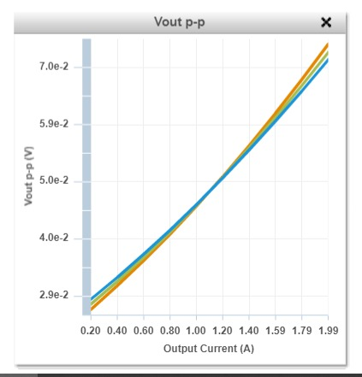

Figure x - Efficiency vs Output Current Graph of TSP61088.

Figure x - Output Voltage Ripple vs Output Current Graph of TSP61088.

*Table 1 – Operating value parameters of TSP61088*

|  |  |
| --- | --- |
| **Inductor Current Peak to Peak Value** | 8.204 A |
| **Output Voltage Peak to Peak Value** | 0.074 V |
| **Efficiency** | 95.78 % |
| **IC Junction Temperature** | 53.3 **° C** |
| **Mode** | Boost CCM |
| **Footprint** | 123 mm2 |
| **BOM Cost** | $3.52 |

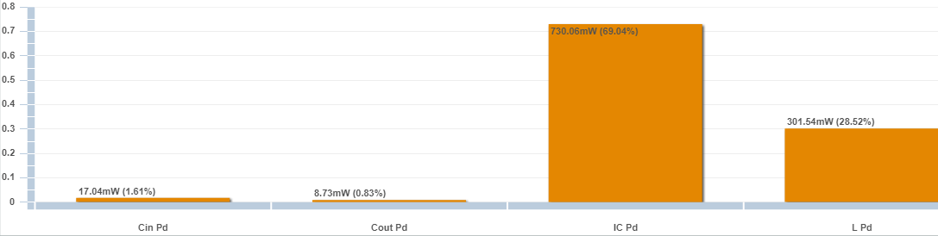

Figure x – Power loss of each element in the circuit of TSP61088.

Where, **Cin Pd** = Input capacitor power dissipation, **Cout Pd** = Output capacitor power dissipation, **IC Pd** = IC power dissipation and **L Pd** = Inductor power dissipation.

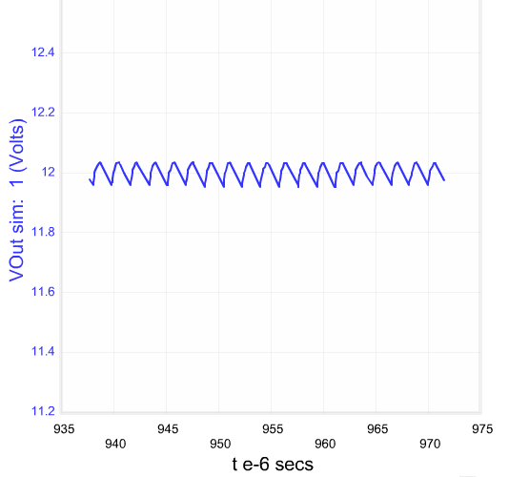

Figure x - Output Voltage vs Time Graph for Steady-State operation of TSP61088.

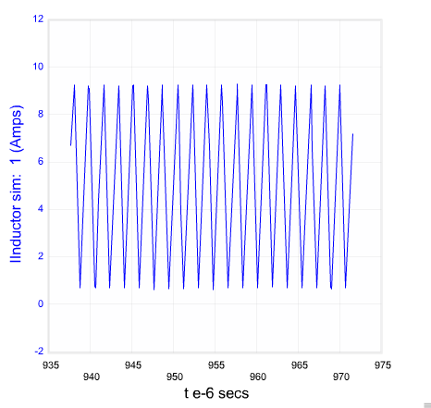

Figure x - Inductor Current vs Time Graph for Steady-State operation of TSP61088.

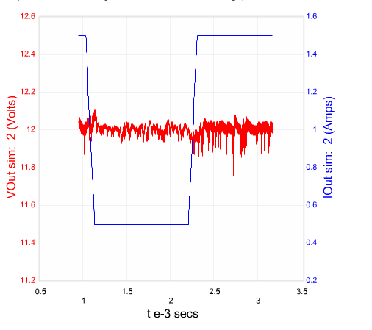

Figure x - Output Voltage & Load Current vs Time for Load Transient operation of TSP61088.